**Experiment No. 2.2**

**Student Name: Rishav Kumar UID: 22MCC20039**

**Branch: MCA - CCD Section/Group: MCD-1/ Grp A**

**Semester: III Date of Performance: 26th Sep 23**

**Subject Name: DevOps Process Automation Lab Subject Code: 22CAP-745**

1. **Aim/Overview of the practical:**

A. Write a Scripted Pipeline to execute the build pipeline with all the 9 goals of Maven.

B. Execute the Scripted Pipeline via Scripted Pipeline with SCM. Name the file as Jenkinsfile and build a pipeline.

**Code for practical:**

**A.**

* Open Jenkins on localhost and login with your credentials.
* Go to ***Manage Jenkins>Plugins*** and install build pipeline plugin.
* Click on ***New item > Pipeline***.
* Select ***Definition > Pipeline script***
* Write pipeline script as follows.

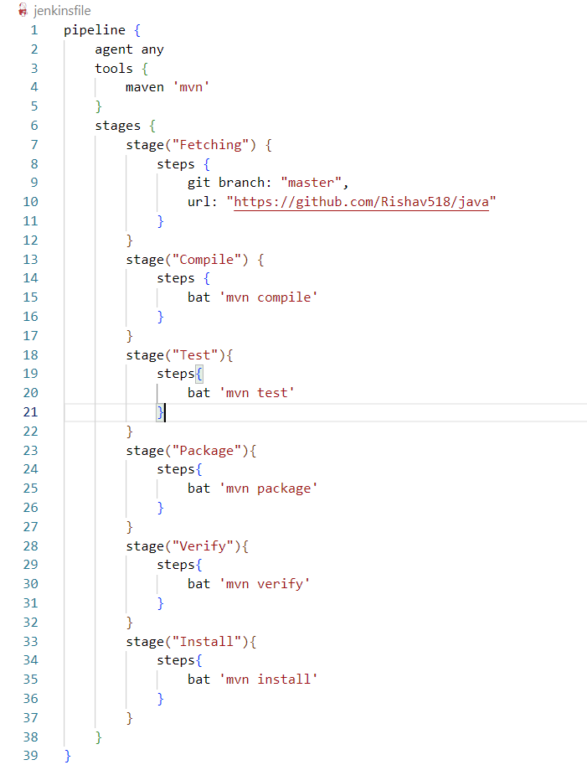

* Click on Save and Build now.
* Pipeline will be built in some moments.

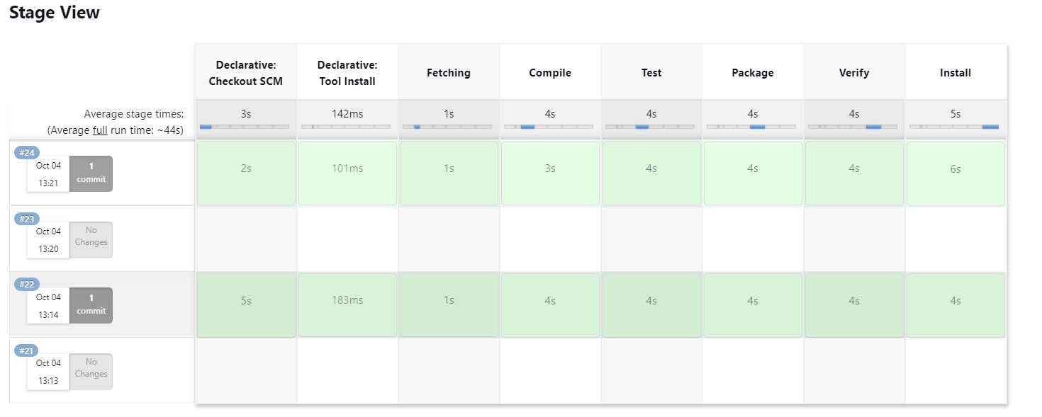

**B.**

* Open Jenkins on localhost and login with your credentials.
* Click on ***New item > Pipeline***.
* Select ***Definition > Pipeline script from SCM> Git***.
* Enter GitHub repository URL and select branch

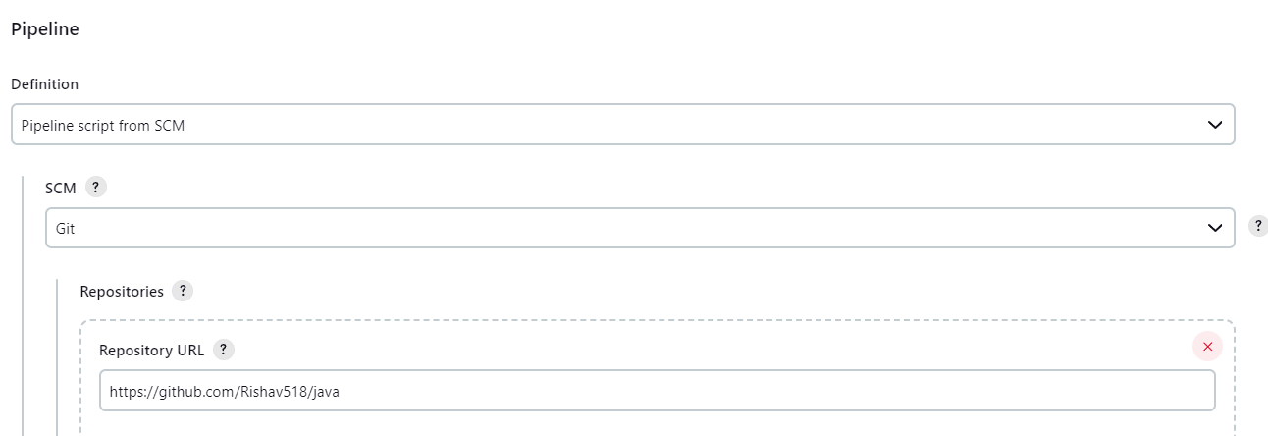

* Create a Jenkinsfile and paste scripted pipeline and commit to github.
* In script path add Jenkinsfile.

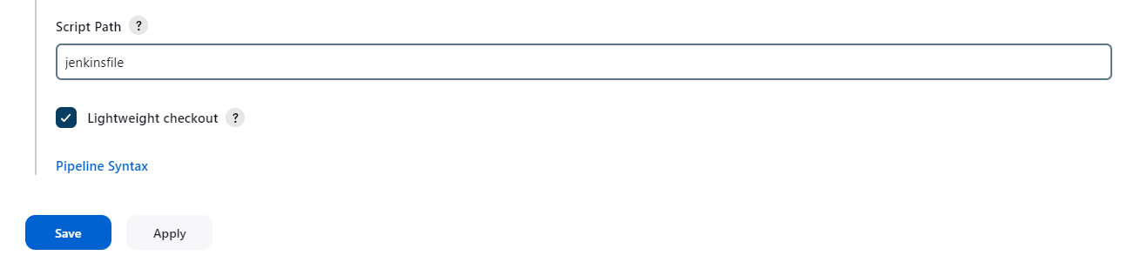

* Save pipeline and click on build now.
* Pipeline will be built in some moments.

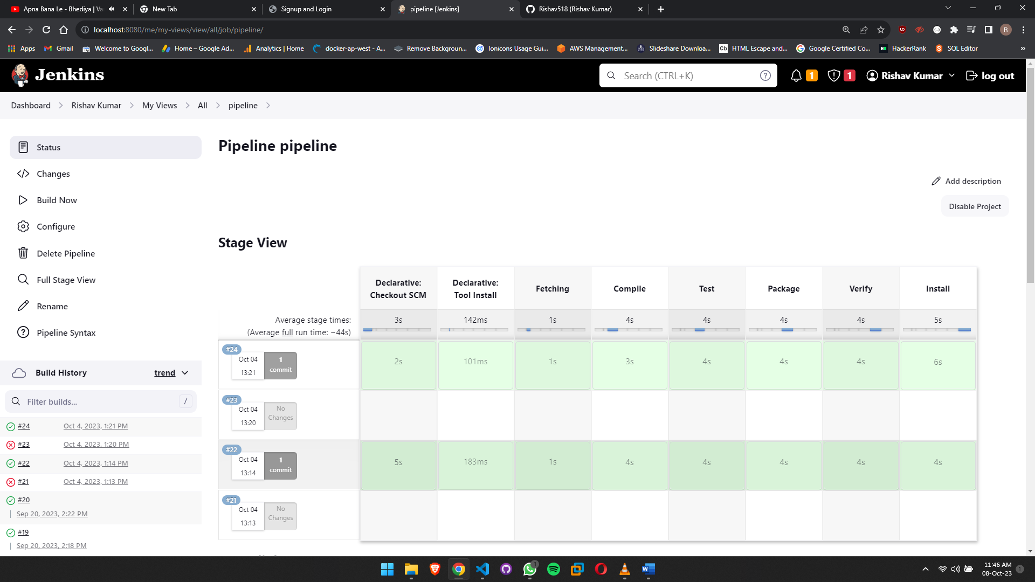

**************************************** **THE END** ***********************************************